# Case study

In this application, customers signup for an account and receive a confirmation on the email with the log-in credentials. The customer then log-in by using the same credentials and then select the option to Dine in or Online Order - further categorized into Self Pickup or Delivery. After choosing the appropriate mode, the customer selects the food and confirms the order. Users can choose the option to skip ordering before proceeding with the payment. And if the payment mode has been selected, the user can further determine a reliable payment option to complete the order. In the case of Delivery, the user must not be advised to make the payment and provided with the opportunity to visit the restaurant. During the food delivery option, the customer must get an order confirmation after the payment, and the chef must receive the list of food to be prepared. Once the chef confirms the system, the delivery person must accept the announcement. The same notification must be provided to the customer that the food has been prepared and out for Delivery. Once the Delivery person delivers the food, the user and restaurant manager must receive a confirmation for the successful completion of an order. In this application, the restaurant manager will use the application to use an advanced calculator to calculate some of the equations they need during the restaurant operations.

# Programming Solution

This program should enable the logged in user to place orders through the App. In response to the

covid safety measures, the restaurant is offering the customers the following possibilities of contactless placing of orders:

1- Dine in: While at restaurant users place contactless orders. Users have to pay additional

service charges to their orders.

2- Pick up: users place remote orders to be picked up either to save the delivery costs or

because the restaurant does not deliver to their address.

3- Delivery: users place remote orders and have them delivered to their address. Users have to

pay extra delivery charges.

The program should follow the below general structure:

When a user runs the program, the below choices should be provided:

1- Sign up.

2- Sign in: upon successful login the users can then do the following.

* Ordering (Dine in, Takeaway, Delivery),
* Print Statistics
* Logout

3- Quit

# Task 1. Signup/Sign in Process for Customers

A user should sign up to use the services provided by the app. Before placing an order, the user

should successfully login to the application. Please create a signup and a login function while making

## 1. Signup

Step 1: Each Customer is advised to submit the required details for signup process.

a. The mobile number has 10 digits starting with 0.

b. The Password must initiate with alphabets followed by either one of @, & and

ending with numeric. (For Example: Sam&0125)

c. The password confirmation matches the initial entered password.

d. The DOB is in the format DD/MM/YYYY

e. The user is at least 16 years old. The age should be calculated based on the

year entered in the DOB (Only consider year).

Note: If any of the above-mentioned condition is not fulfilled; the sign-up process should

fail, and a descriptive message should be displayed for the user explaining what has gone

wrong and providing hints on the correct expected input. The program should keep asking

the user to re-enter his details as long as one or more of the input fields are not correctly

filled. If all fields are completed successfully, the program should stop asking the user to re-enter his details and display a message that the signup process is completed successfully.

If all of the above-mentioned conditions are successful, the user data is saved in Lists to

enable data checks during the login process.

Step 2: There is an additional field for entering the address, (Optional)

Step 3: Submit

Step 4: A message of Signup Successful must be displayed.

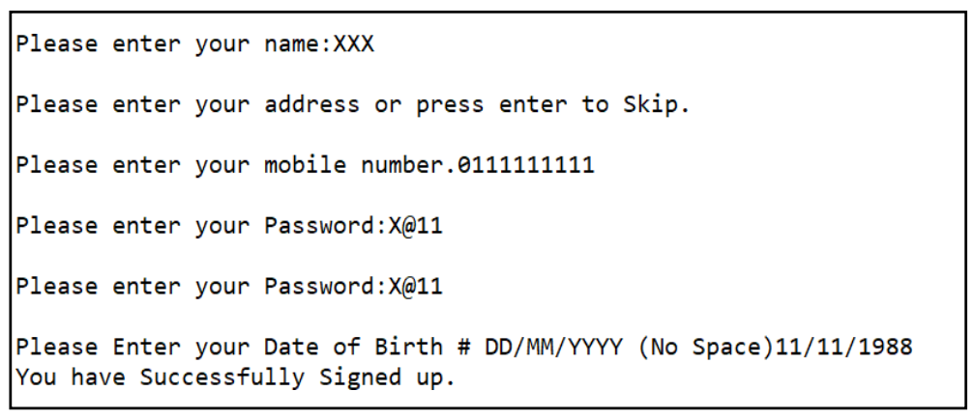

# 2. Sign in.

Step 1: Each customeris advised to enterthe login id and password forthe sign in,

Step 2: Post Successful Login the User must be presented with a variety of options to

Proceed (Home Page):

2.1 Ordering (Dine in, Self-Pickup, Delivery),

2.2Summary of Transactions

2.3Logout

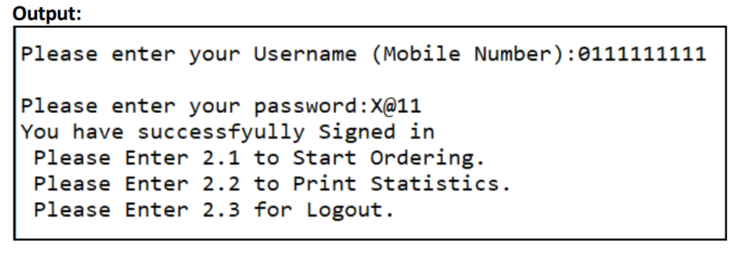

# Task 2: Ordering

Post Selecting the Option of 2.1 the User must be taken to the Ordering Page. In the ordering page,

the following options should be offered:

1 Dine in

2 Order Online

3 Go To Login Page

In case of Selecting the Option 2, the User must be taken to the next page, where the following

options should be offered:

1 Self-Pickup

2 Home Delivery

3 Go To Previous Menu

After the user successfully selects the ordering mode, the user should be presented with

the menu in the form of:

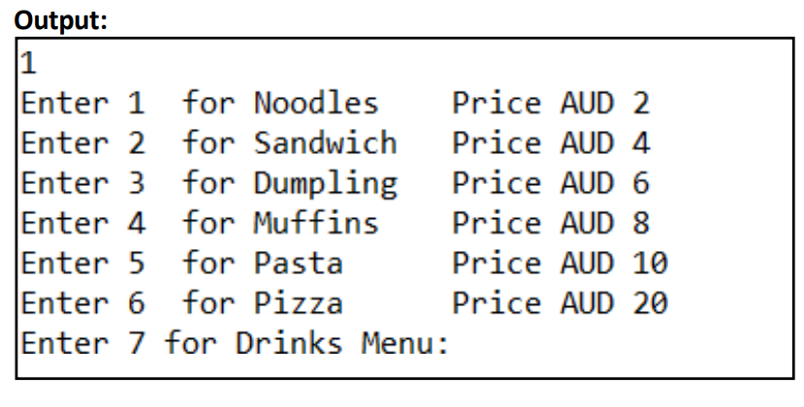

Please note:

• The menu will only have 6 items for the Click and collect and delivery modes.

• If dine in mode is selected the user menu should have 6 items followed by 3 drinks items

presented after the Food Menu.

• The user should be able to order as many items as they wish. To close the Food menu and

proceed to theDrink Menu the user needsto select option 7.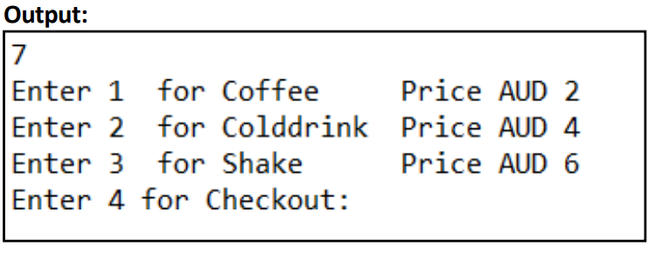

• To close the Drink Menu and proceed to the Checkout the user needs to select option 4.

• Post Checkout the user must be advised with the total amount needed to be paid.

• The user will then be provided with three options:

o Proceed with payment.

o Cancel order.

